

**Version Control**

**History**

**for**

**Library Information Application**

**Version: 1.0**

**Date: 18/06/10**

**20143692 강경석**

**20144103 조유성**

**20145026 김상범**

**20141043 양준호**

**20146110 문태현**

**20143583 김기환**

Table of Contents

Index

[Library information appliciation]

Version 1.0

June 10, 2018

1.Version 1.0

1.1 version 1.1

1.2 version 1.2

1.3 version 1.3

1.4 version 1.4

1.5 version 1.5

1.2 version 1.6

1.3 version 1.7

1.4 version 1.8

1.5 version 1.9

2. Version 2.0

**Version 1.0**

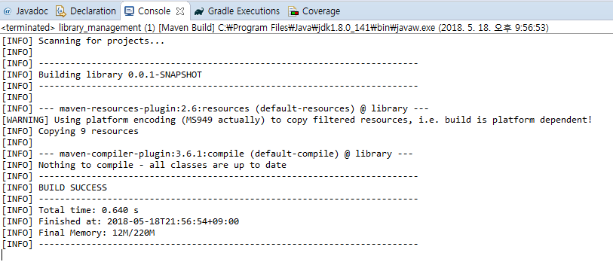

**Version 1.1**

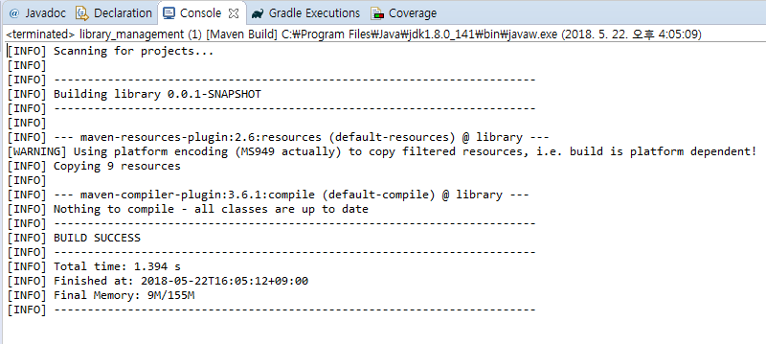

**Version 1.2**

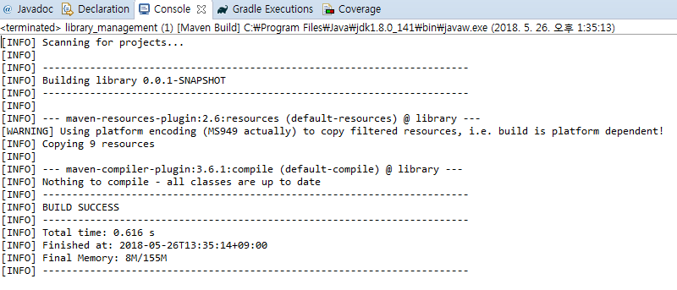

**Version 1.3**

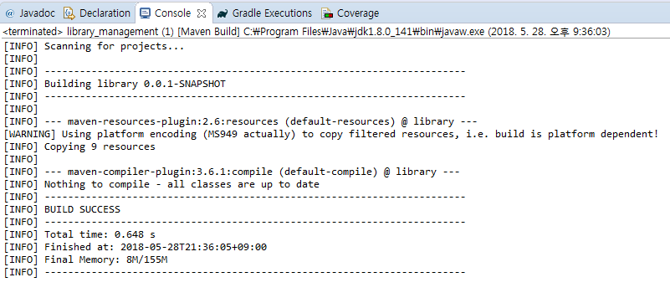

**Version 1.4**

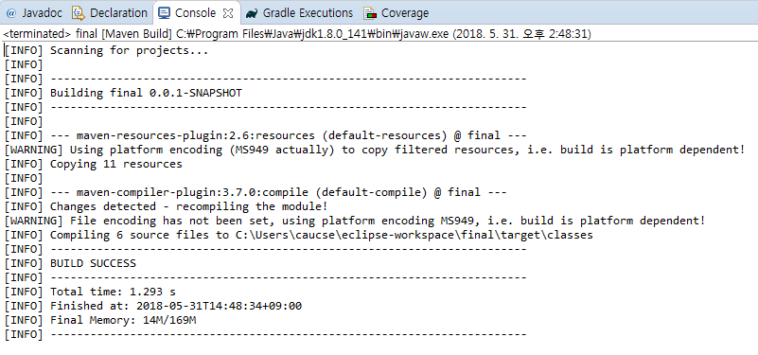

**Version 1.5**

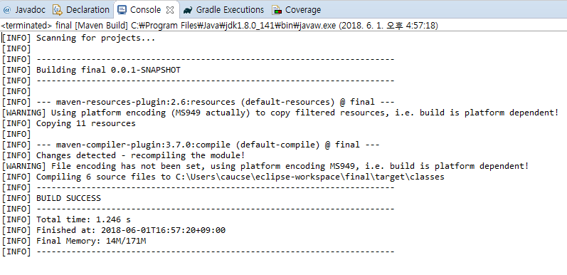

**Version 1.6**

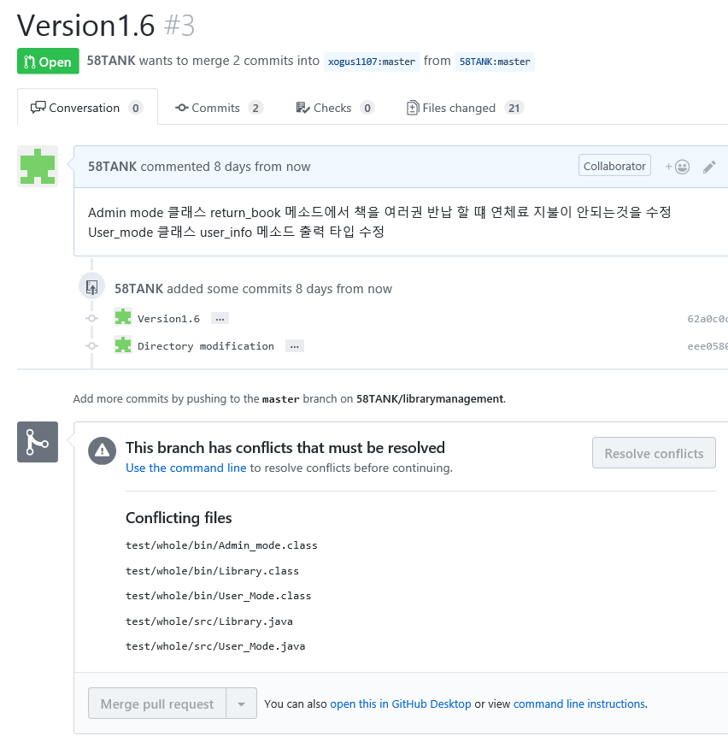

**Version 1.7**

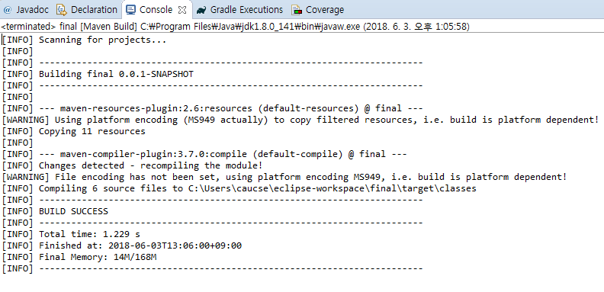

**Version 1.8**

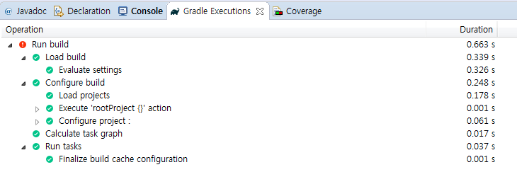

**Version 1.9**

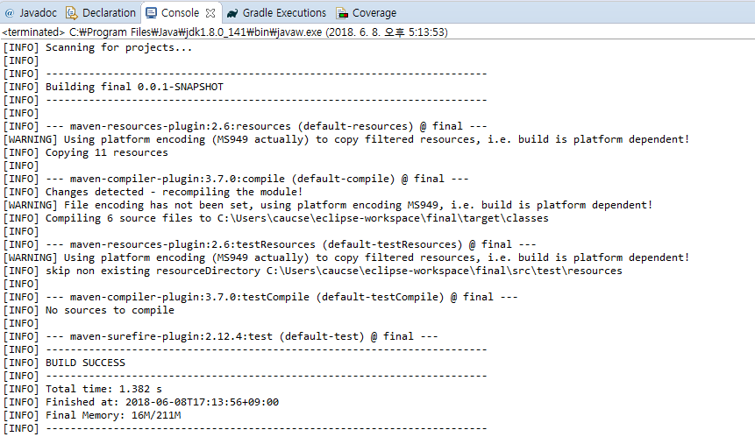

**Version 2.0**